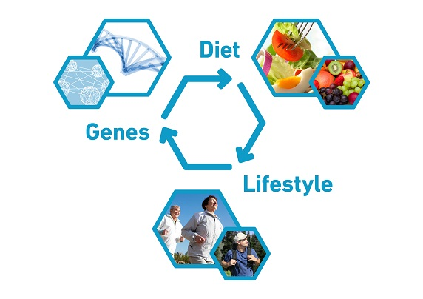

**Nutrition and Metabolism**

**Graduate Program Presents:**

Advances in Human and Clinical Nutrition

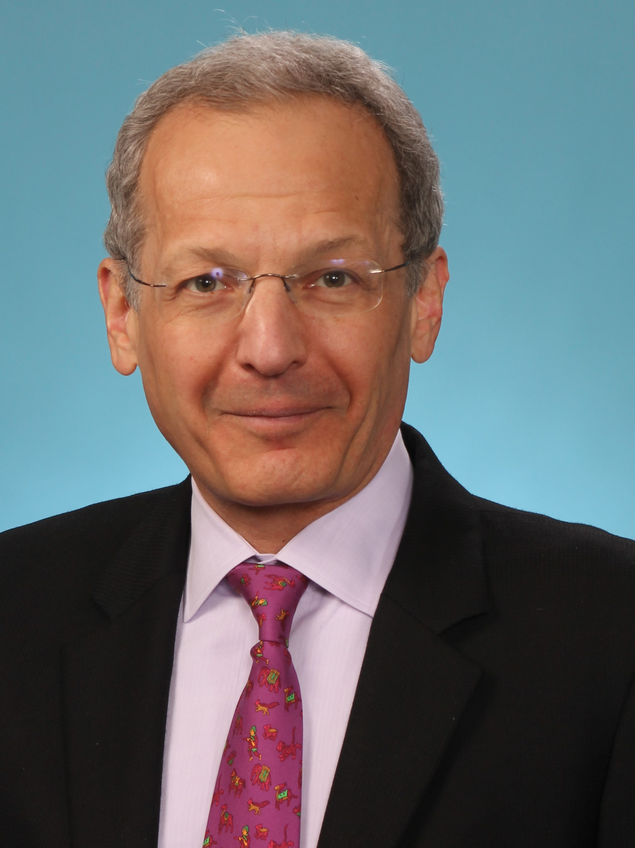

Samuel Klein MD

William H. Danforth Professor of Medicine and Nutritional Science

Center for Human Nutrition

Washington University School of Medicine

Metabolic Healthy and Unhealthy Obesity

and Response to Weight Loss

March 13, 2025

11 AM

Nutritional Sciences Room 290